1. Genereate_recepit (New Unique function/feature)
   1. void generate_receipt(Organization org, const char* folderPath, const char* fileSuffix);
   2. Generates a receipt once the organization is made
2. ReplaceSpaces(New Unique function/feature)
   1. void replaceSpaces(char* str);
   2. Replaces all spaces in a string with dashes (for convenience) by searching each character in a string for spaces using a for loop
3. deallocateList (New Unique function/feature)
   1. void deallocateList(Node** head);
   2. Deallocates all the memory from the linked list by iterating through each node in the list, setting it equal to current node, and than using the free command to free it)
4. createFolderPath (New Unique Function/feature)
   1. char* createFolderPath(const char* folderPath, const char* fileSuffix, char orgName[]);
   2. Creates a folder path given the orgName, by using the folderPath and fileSuffix constants, than using strcpy and strCat to form it into one big file line
5. sortOrgs (New Unique function/feature)
   1. void sortOrgs(Node** head);
   2. Sorts the organizations alphabetically, by using two different notes and a bubble sort, to swap and organize each node (org) in the linked list
6. addNode(New feature but not original)
   1. void addNode(Node** head, Organization org);
   2. Takes the node head and adds the current org stored into the linked list
7. chooseOrganization(New feature but not original (output taken from assignment sheet)
   1. Organization* chooseOrganization(Node* head);
   2. Iterrates through the list with a temp variable current node and displays each org with it, than after the node is reset and the user choose a org, than using a while loop, the list is iterarated through again to see of the orgname and the name the users entered in match, if they do the while loop ends and that node is returned into the organization, if it does not exist the user is re-prompted and it goes through again.
   3. Design
      1. 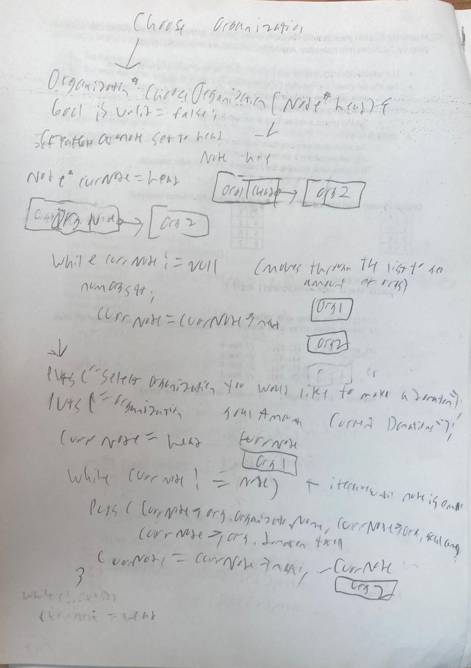
      2. 